DSA Practice Report

|  |  |
| --- | --- |
| Student ID | 18511160023 |
| Student Name | EMETUCHE WINNER CHIDIUTO |
| Practice No. | 8 |
| Practice Title |  |
| Date |  |
| Place | 5B213 |
| Mark |  |
| Checked by | Wingo WU |

# Object Composition (in stack)

## Objects

1. to learn well the object composition
2. To learn well property of the object in stack and its problem related to it
3. to learn well the difference object and object pointer

## Problems

### triangle class

A triangle is built by 3 points. Design a class for Point and a class for Triangle. A triangle class contains 3 points. Triangle and point are composition relationship.

Test your class with the following triangles. You can determine the coordinates for p1,p2,p3 and p4 yourself. In your program, output the information of each triangle: coodinates of three points. Valid your result. Is it correct or not? Point out the problem in your program.

p1

p2

p3

p4

p1

p2

p3

p4

void Test()

{

Point p1(1,0),p2(3,0),p3(3,3),p4(1,3);

Triangle t1(p1,p2,p3), t2(p1,p3,p4);

t1.show();

t2.show();

p1.MoveTo(0.5,0.5);

t1.show();

t2.show();

}

## Results

### Results for Problem 1

**Algorithm Result:**

**//----18511160023 EMETUCHE WINNER CHIDIUTO**

**//----Practice 8,**

**#include<iostream>**

**#include<math.h>**

**using namespace std;**

**class Point{**

**double x,y;**

**public:**

**Point():x(0),y(0) { }**

**Point(double x1,double y1):x(x1),y(y1) { }**

**void Move(double dx,double dy) {**

**x+=dx;**

**y+=dy;**

**}**

**friend ostream & operator <<(ostream &out,Point &p);**

**~Point() { }**

**};**

**ostream & operator <<(ostream &out,Point &p){**

**out<<"("<<p.x<<","<<p.y<<") ";**

**return out;**

**}**

**class Triangle{**

**Point p1,p2,p3;**

**public:**

**Triangle():p1(0,0),p2(0,0),p3(0,0){ }**

**Triangle(double x1,double y1,double x2,double y2,double z1,double z2):**

**p1(x1,y1),p2(x2,y2),p3(z1,z2){ }**

**Triangle(Point p1a,Point p2a,Point p3a):p1(p1a),p2(p2a),p3(p3a){**

**}**

**friend ostream & operator <<(ostream &out,Triangle &t);**

**double GetArea();**

**};**

**ostream & operator<<(ostream &out,Triangle &t){**

**out<<t.p1<<" "<<t.p2<<" "<<t.p3<<endl;**

**return out;**

**}**

**int main(){**

**Point a(1,0),b(3,0),c(3,3),d(1,3);**

**Triangle t1(a,b,c);**

**Triangle t2(a,c,d);**

**cout<<"**** Test your class with the following triangles ****\n";**

**cout<<"**** Values Before moving points: ****\n"<<endl;**

**cout<<"Triangle 1:"<<t1;**

**cout<<"Triangle 2:"<<t2;**

**cout<<"Move a Point from ";**

**cout<<a;**

**a.Move(0.5,0.5);**

**cout<<" to "<<a<<endl;**

**cout<<"**** Result after moving Values from points: ****\n"<<endl;**

**cout<<"Triangle 1:"<<t1;**

**cout<<"Triangle 2:"<<t2;**

**getchar();**

**return 0;**

**}**

[Your screen shot]

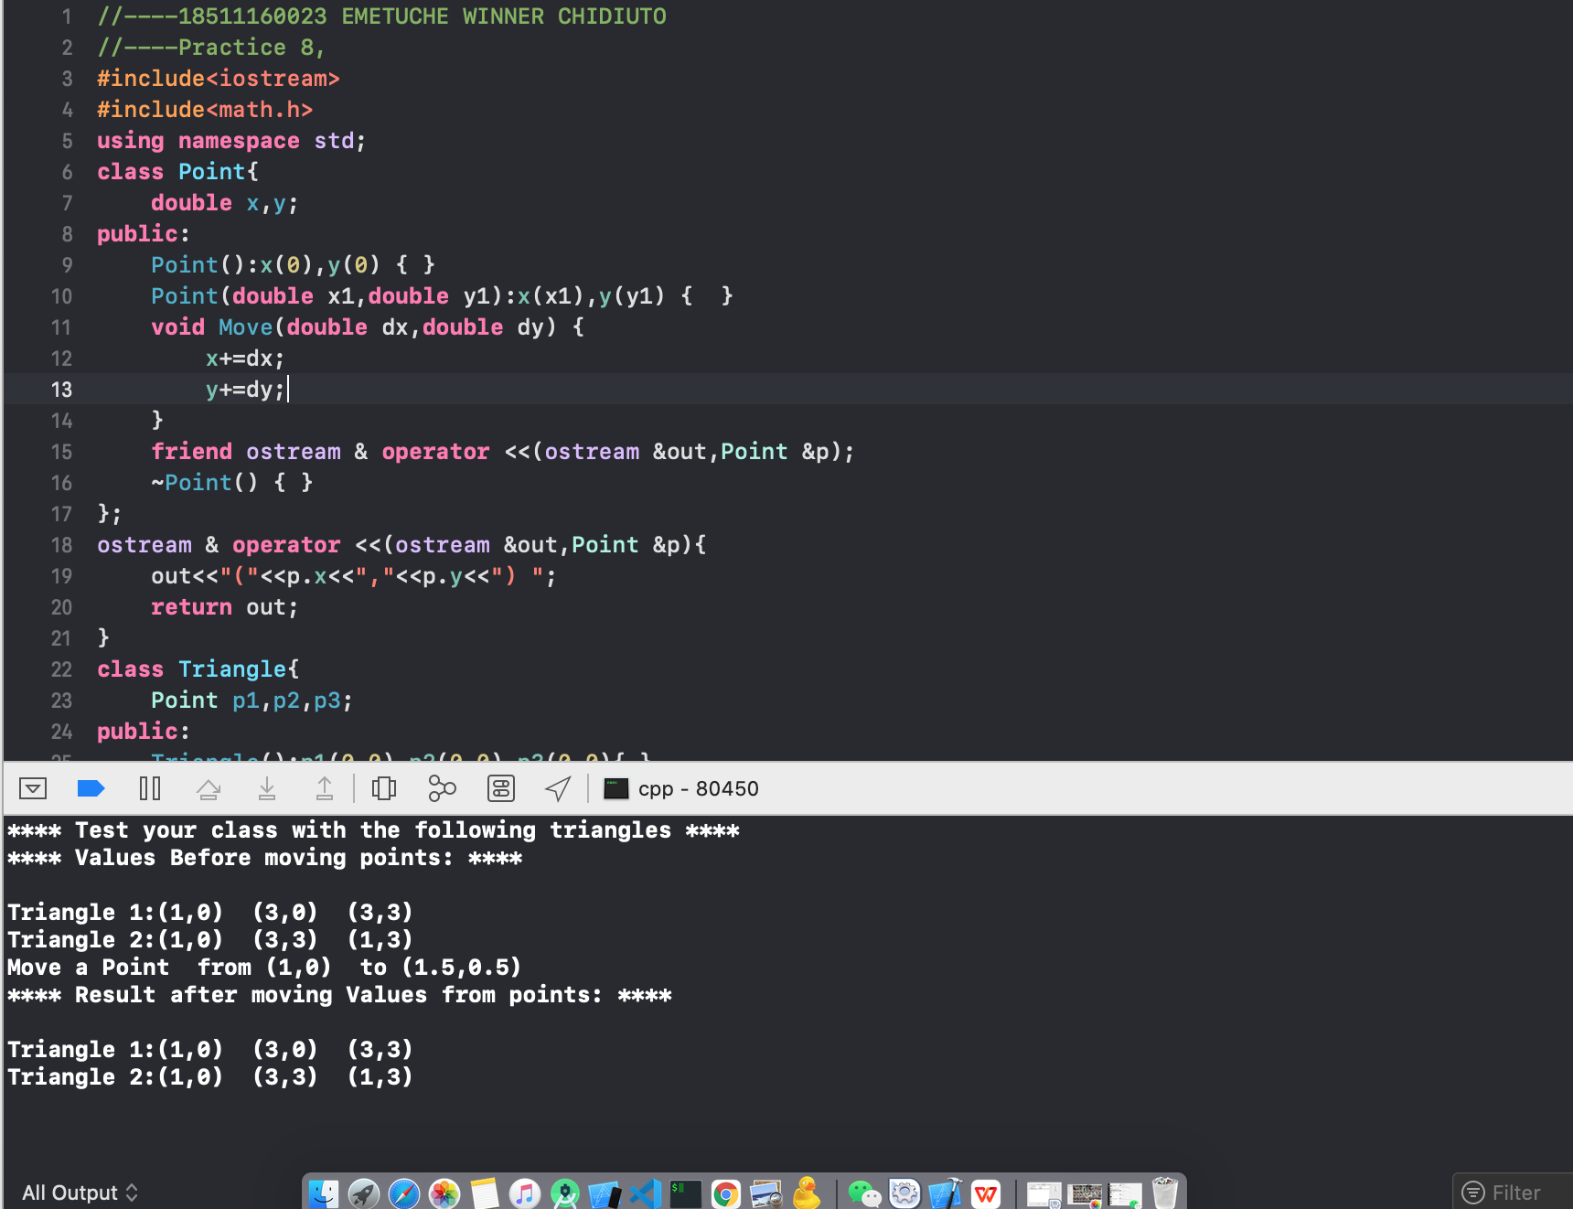

### Results for Problem 2

**Algorithm Result:**

**//----18511160023 EMETUCHE WINNER CHIDIUTO**

**//----Practice 8,**

**#include<iostream>**

**#include<math.h>**

**using namespace std;**

**class Point{**

**double x,y;**

**public:**

**Point():x(0),y(0) { }**

**Point(double x1,double y1):x(x1),y(y1) { }**

**void Move(double dx,double dy){**

**x+=dx;y+=dy;**

**}**

**friend ostream & operator <<(ostream &out,Point &p);**

**~Point() {**

**}**

**};**

**ostream & operator <<(ostream &out,Point &p){**

**out<<"("<<p.x<<","<<p.y<<") ";**

**return out;**

**}**

**class Triangle{**

**Point *p1,*p2,*p3;**

**public:**

**Triangle():p1(NULL),p2(NULL),p3(NULL){**

**}**

**Triangle(Point *p1a,Point *p2a,Point *p3a):p1(p1a),p2(p2a),p3(p3a){**

**}**

**friend ostream & operator <<(ostream &out,Triangle &t);**

**double GetArea();**

**};**

**ostream & operator<<(ostream &out,Triangle &t){**

**out<<(*t.p1)<<" "<<(*t.p2)<<" "<<(*t.p3)<<endl;**

**return out;**

**}**

**int main(){**

**Point *a=new Point(1,0),*b=new Point(3,0),*c=new Point(3,3),*d=new Point(1,3);**

**Triangle t1(a,b,c);**

**Triangle t2(a,c,d);**

**cout<<"**** Before moving Values from points: ****\n"<<endl;**

**cout<<"Triangle 1:"<<t1;**

**cout<<"Triangle 2:"<<t2;**

**cout<<"Move a Point from ";**

**cout<<*a;**

**a->Move(0.5,0.5);**

**cout<<" to "<<*a<<endl;**

**cout<<"**** Result after moving Values from points: ****\n"<<endl;**

**cout<<"Triangle 1:"<<t1;**

**cout<<"Triangle 2:"<<t2;**

**delete a,b,c,d;**

**getchar();**

**return 0;**

**}**

**Screenshot Result:**

